VULCAN INSIGHT
AI Solution Proposal
Prepared for Vulcan Werk • June 2026
SilverTrust AI Consulting

Status  Confidential | Version  1.0 — Draft for Review | Contact  SilverTrust AI Consulting

1. Executive summary
Vulcan Werk's production lines generate data across 5 separate systems with incompatible schemas. Getting a complete picture requires one person to assemble it by hand — which means defects, outages, and rework are found after the damage is already done. ISO 9001 audit preparation runs through the same bottleneck.
Vulcan Insight fixes this with an on-prem data layer that unifies all 5 sources, routes clean business context to 3 AI agents, and produces audit-ready records — without moving raw data off-site or taking any automated action on the shop floor.
The system is classified as minimal risk under the EU AI Act. Every AI output requires human review before use. Log and work-time data that touches employee protection under GDPR is handled at ingestion with role-based access and pseudonymization.

The AI receives only filtered, pre-aggregated context — never raw production databases or customer records. Every output is traceable to its source.

2. The problem
Persona | Pain point | Business consequence
Mira  Production Manager | - Data from 5 systems in different formats, assembled by hand.  - Outages found after the line stops — rework cost compounds.  - No live view of line performance. | - Margins erode on every late detection.  - One technician bottlenecks all reporting for 3 lines.
Markus  IT / Shopfloor Tech | - 3 DEV-network databases with incompatible schemas.  - GDPR and NDA constraints block raw data leaving the building.  - Cloud tools refused — on-prem and read-only are hard requirements. | - Integration complexity lands on 1 person.  - Any solution touching raw data externally is a non-starter.
Ellen / Ingrid  Compliance & QM | - ISO 9001 audits need clean, timestamped, traceable records.  - Log and work-time data triggers GDPR employee protection rules.  - Every flagged incident needs a named human sign-off. | - Audit prep is slow and hard to verify against source.  - Inconsistent evidence blocks certification renewals.

3. Solution architecture
The platform has 4 layers. Layers 1–3 are standard software — fast, deterministic, and auditable. The AI sits only in Layer 4, and it only ever sees pre-filtered business context, not raw machine data.

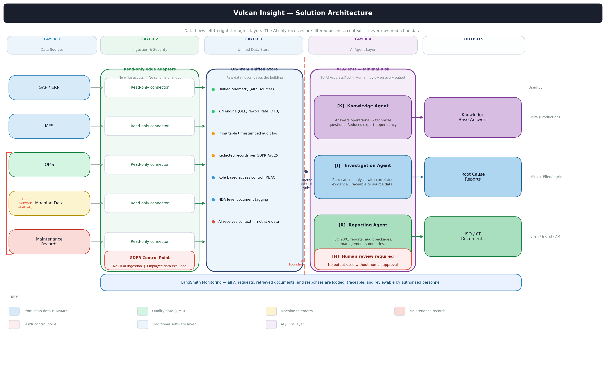
Figure 1 — Vulcan Insight system architecture. Data flows left to right. The red dashed line marks the AI boundary.
How the 4 layers work

# | Layer | What it does | Technology
1 | Data sources  SAP, MES, QMS, Machine data, Maintenance records | - 5 production systems, 3 on a separate DEV network with incompatible schemas (A≠B≠C).  - None are changed, modified, or written to. | Existing systems unchanged
2 | Ingestion & security  Read-only edge adapters | - Read-only connectors extract data without touching source schemas.  - GDPR filter applied at ingestion: no PII enters the store. Employee-linked records (log files, work-time data) are pseudonymized or excluded.  - NDA-level tags assigned to every document at ingestion. | Standard software — no AI
3 | Unified data store  Single on-prem source of truth | - All 5 sources consolidated in one local store. Raw data never leaves the building.  - KPI engine runs calculations: OEE, rework rate, downtime, on-time delivery.  - Immutable audit log with timestamps. Records redacted per GDPR Art. 25 data minimisation.  - Role-based access control: users only query data they are authorised to see. | Standard software — no AI
4 | AI agent layer  Knowledge, Investigation, Reporting | - 3 agents receive only aggregated, pre-filtered business context — never raw telemetry.  - Context package includes: KPI values, event correlations, relevant document excerpts.  - Every output requires human review before it is used or stored.  - EU AI Act classification: minimal risk (no automated decisions, no machine control). | AI — minimal risk (EU AI Act)

The AI boundary — what the AI sees and what it does not
The red dashed line in the diagram marks the boundary of the AI layer. This boundary is a design constraint, not a configuration option.

The AI receives | The AI never receives
- KPI values (e.g. rework 3.2% → 7.4%)  - Event correlations (e.g. torque alarms +38%)  - Relevant document excerpts (NDA-checked)  - Aggregated shift summaries  - Maintenance event timestamps | - Raw telemetry streams  - Customer or OEM data  - Employee names, log files, or work-time records  - Complete production databases  - Any data the requesting user is not authorised to see

Example: a query through the system
Mira asks: "Why did rework increase on Line 3 last week?"

Step | Action | What happens
1 | Permission check | System verifies Mira has read access to L3 production data and the QMS for that week.
2 | Data selection | Retrieves L3 rework events, torque station logs, maintenance records, and QMS entries for the period.
3 | KPI calculation | KPI engine computes: rework rate moved from 3.2% to 7.4%. Torque station alarms up 38%. Maintenance intervention logged Tuesday.
4 | Context package | Aggregated numbers, event timeline, and a flag that a similar incident occurred in March are assembled. No raw data included.
5 | AI analysis | Investigation Agent receives the context package and identifies the torque station correlation. Similar March event surfaced.
6 | Human review | Mira reads the output, confirms the root cause, and approves the investigation report. The approval is logged in LangSmith.

The 3 AI agents

Agent | What it answers | Business value
[K] Knowledge Agent  Fast access to operational knowledge | - Which system holds downtime data?  - How is OEE calculated here?  - What does ISO 9001 require for this field? | - Reduces dependency on 1–2 key experts.  - New team members get answers in seconds.  - Institutional knowledge retained when people leave.
[I] Investigation Agent  Root cause support with evidence | - Why did rework on L3 increase last week?  - Were there similar incidents in the past 6 months?  - What changed before the Tuesday downtime? | - Cuts investigation time from hours to minutes.  - Surfaces correlated events the manual process misses.  - Every finding is traceable to source data.
[R] Reporting Agent  Automated report preparation | - ISO 9001 quality reports.  - Management summaries and shift handovers.  - Audit preparation packages. | - Report preparation drops from days to hours.  - Output fields match ISO 9001 requirements directly.  - Audit evidence is consistent and verifiable.

Every AI-generated output is labelled as AI-generated until a human confirms it. The label is removed only when an authorised person approves. That approval is timestamped and stored in the audit log.

4. GDPR and data protection
The platform handles 5 categories of data, each with a defined lawful basis and control.

Data element | Lawful basis (Art. 6) | Control | Retention
Machine & OEE telemetry | Legitimate interest (6(1)(f)) | Aggregated before AI sees it; raw data stays on-prem | Defined per data category
User accounts / names | Legitimate interest (6(1)(f)) | RBAC; only own records visible | Duration of employment + 1 year
Log files & work-time data | Legitimate interest (6(1)(f)) + employee protection review | Pseudonymized at ingestion; excluded from AI context | 90 days, then anonymized
Maintenance records | Legitimate interest (6(1)(f)) | Redacted where employee names appear | 2 years (ISO 9001 requirement)
NDA / customer data | Contractual obligation (6(1)(b)) | NDA tag applied at ingestion; AI access blocked unless user is cleared | Per NDA terms

A DPIA is required before pilot launch. It will cover: data flows for all 5 source types, retention periods, the employee protection analysis for log and work-time data, and data subject rights handling.

5. NDA and intellectual property
Control | How it works
On-premises deployment | Nothing runs in the cloud. Raw data never leaves the building. The local store is the only copy.
Document classification | Every document in the knowledge base is tagged with an NDA level. The AI retrieves only what the requesting user is cleared to access.
Full audit trail | Every AI request, document retrieved, and response generated is logged. Authorised personnel can trace any output back to its source.

6. EU AI Act classification
Dimension | Assessment
Risk tier | Minimal risk
Justification | - No automated decisions — human review required at every output.  - No machine or physical control.  - No employee evaluation or scoring.  - No safety-critical operations.
Role allocation | SilverTrust AI Consulting = Provider. Vulcan Werk = Deployer.
Transparency | Users are informed they are interacting with an AI system at every session. Output is labelled AI-generated until a human confirms it.

7. AI monitoring with LangSmith
LangSmith monitors the AI system, not the production systems. Every AI action is logged and reviewable.

What is tracked | Why it matters
User request | Full text of every query, timestamp, and user role.
Documents retrieved | Which records the system selected for the context package.
Generated response | The exact output the AI produced before human review.
Human review outcome | Whether the output was approved, rejected, or modified.
Latency and errors | System health and performance baseline for each agent.
User feedback | Approved / rejected per output, fed back into evaluation scores.

If a regulator asks what the system did on a specific date, the full trace — query, context package, AI response, and human approval — is in LangSmith.

8. Recommended next steps
# | Step | Detail | Owner
1 | Schema mapping workshop | Document all 5 source schemas; confirm DEV-network access method for A, B, C. | Markus + SilverTrust
2 | DPIA | Complete data protection impact assessment covering employee-protected records and retention periods. | Ellen / Ingrid + SilverTrust
3 | L1 pilot | Deploy ingestion layer and Knowledge Agent on Line 1 only. Measure investigation time and alert latency. | Mira + SilverTrust
4 | Shadow mode (4 weeks) | Run Investigation Agent in parallel. Moderator reviews all outputs. Adjust thresholds before go-live. | Mira + Markus
5 | Full rollout | Extend to L2, L3 and activate Reporting Agent once L1 pilot meets agreed KPIs. | All stakeholders

SilverTrust AI Consulting — Confidential — June 2026
This document is prepared exclusively for Vulcan Werk. It may not be shared or reproduced without written consent from SilverTrust AI Consulting.

